Who wants to be

millionaire

(Using

C++)

By:

SHRISHTI GUPTA

(2016KUCP1019)

SHUBHAM GUGLANI

(2016KUCP1018)



Who wants to be

millionaire

CONTENTS

1. ACKNOWLEDGEMENT
2. CERTIFICATE
3. DEVELOPER’S INFORMATION
4. INTRODUCTION ->A) SOFTWARE REQUIREMENTS -

B) COMPILER USED

C) PURPOSE

D) SCOPE

1. FUNCTIONALITIES
2. USE-CASE DIAGRAM
3. SOURCE CODE
4. SNAPSHOTS OF OUTPUT

9) BIBLIOGRAPHY

ACKNOWLEDGEMENT

We would like to thank everyone who is connected with the 'PROJECT' in any form. We would especially like to thank,

Mr. Vikas Yadav for his expert guidance and suggestions

Which helped us in the conception and completion of this

Project.

The Project would not be possible without a large number of valuable suggestions made by him which we had incorporated in this work.

This Project enabled us to learn a lot.

We would also like to thank our parents, our siblings and the almighty without whom, everything is impossible.

Many Online Forums, Portals and Resources Were really helpful

Like -> Stack overflow, Wikipedia, Google ... and much more.

shubham Guglani

&

Shrishti Gupta

CERTIFICATE

This is to certify that” Shubham and Shrishti “who were permitted to work for their project in Department of computer’s, Indian Institute of Information Technology, Kota on the project entitled “Who wants to be millionaire “has faithfully carried out study under my guidance and supervision and the project which they are submitting is their genuine work.

They have completed necessary projects and assignments and put in the required attendance in the computer practical periods.......

Mr. vikas yadav

(oosd TEACHER)

Who wants to be millionaire

------------------------------

DEVS INFO.

------------------------------

--------------------------------------------------------------

Shrishti Gupta (2016kucp1019)

Email- 2016kucp1019@iiitkota.ac.in

Contact No.- 7838186843

College – IIIT Kota (3rd semester)

Shubham Guglani(2016kucp1018)

Email- 2016kucp1018@iiitkota.com

Contact No.- 9540049057

College – IIIT Kota (3rd semester)

CONTACT US - FOR ANY HELP ON THE PROJECT

--------------------------------------------------------------

INTRODUCTION

The project is a game called “Who wants to be millionaire?”. It is based on an international reality show.

Our game basically will contain questions to enhance general knowledge of the player.

Questions in the game cover all the aspects of our past, present and day to day happenings.

It concentrates on the IQ of the player, player with higher IQ will surely be rewarded by handsome amount of money as compared to other people.

A) Software requirements:

=> CODE BLOCKS INTEGRATED DEVELOPMENT ENVIRONMENT.

B) Compiler:

=> DIGITAL MARS COMPILER SUPPORTING C++11.

(Good for GUI and other features.)

c) Purpose:

=> The purpose of the project is to create a virtual environment where school going students as well as college students can play the game to enhance their knowledge of worldly affairs. It helps them analyze their Intelligence Quotient and their position in this world of competition. The game is provided with an interactive interface so that people would feel relaxed and good while playing and side by side will improve their knowledge. This game is designed in such a way that it will provide people a break from their monotonous routines and win a handsome amount of money.

D) SCOPE:

=> The game is compatible with local server only. Basically, this game is so user friendly that even a lay man can understand the rules and regulations so easily. Actually, a person who has a curiosity to gain more and more knowledge can play this game to outshine. Aspirants preparing for MBA and competitive examinations like civil services can use this game for a sure shot success in the examinations. This game can be used in schools and colleges so that the students can have a head start in the race of life with greater knowledge hence having edge over others.

FUNCTIONALITIES

1)The major functionalities are as follows:

\* Player can start a new game by entering his/her name

and age.

\* There are 10 levels in the game and in order to become

a millionaire he/she has to clear all the levels.

\* Each level has a certain difficulty level according to

which a random question will be popped from around

1. -40 questions.

\* 3 lifelines will be provided to the players and each

lifeline can be used only once in a game.

=> Fifty- Fifty

=> Audience poll

=> Expert advice

\* A player can save the game and exit if he/she wants to

continue it later.

\* During a session a player always has an option to quit

the game in this case the amount earned till the given

level will be his total prize money

\* In case of wrong answer, the player will win no money.

“ADDITIONAL FEATURES WILL BE ADDED AS PER AVAILBILITY OF TIME”

SNAPSHOTS of OUTPUT

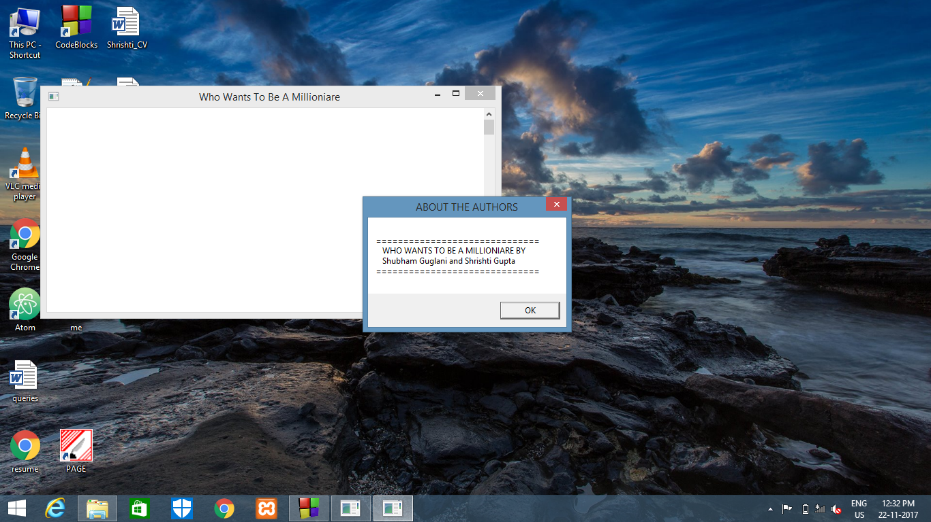

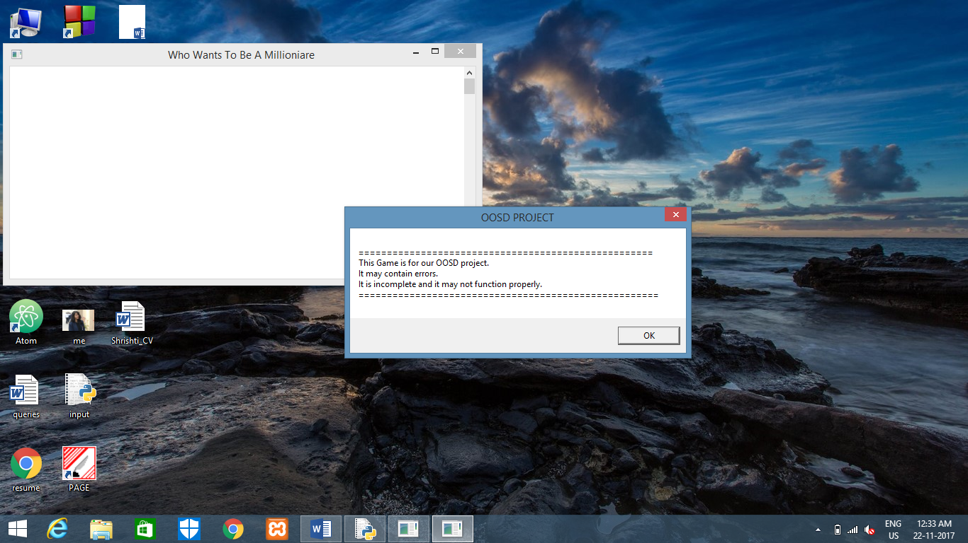

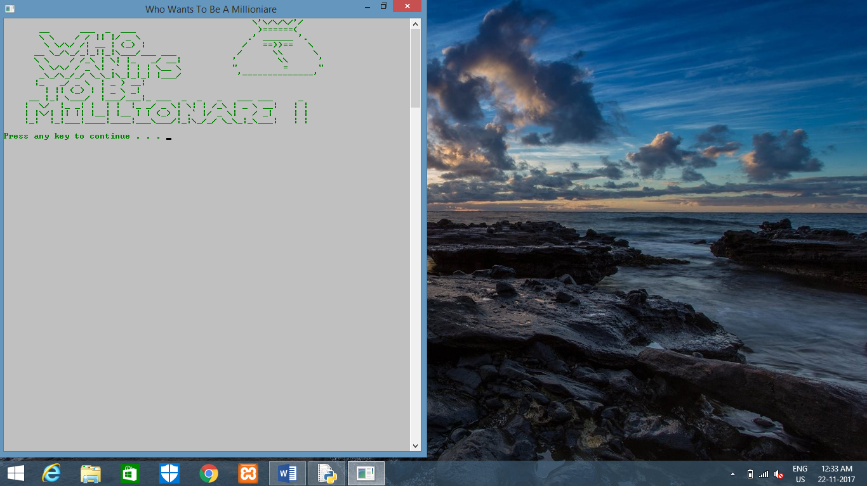

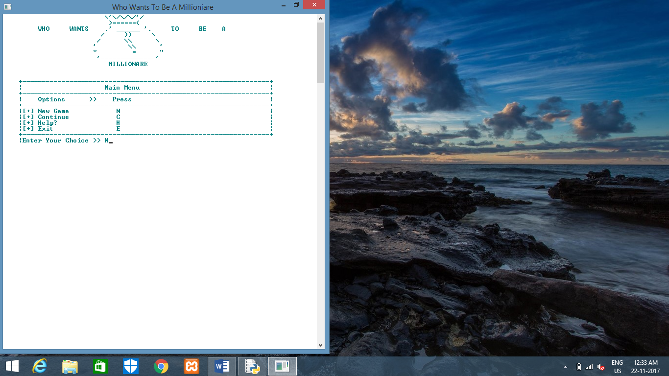

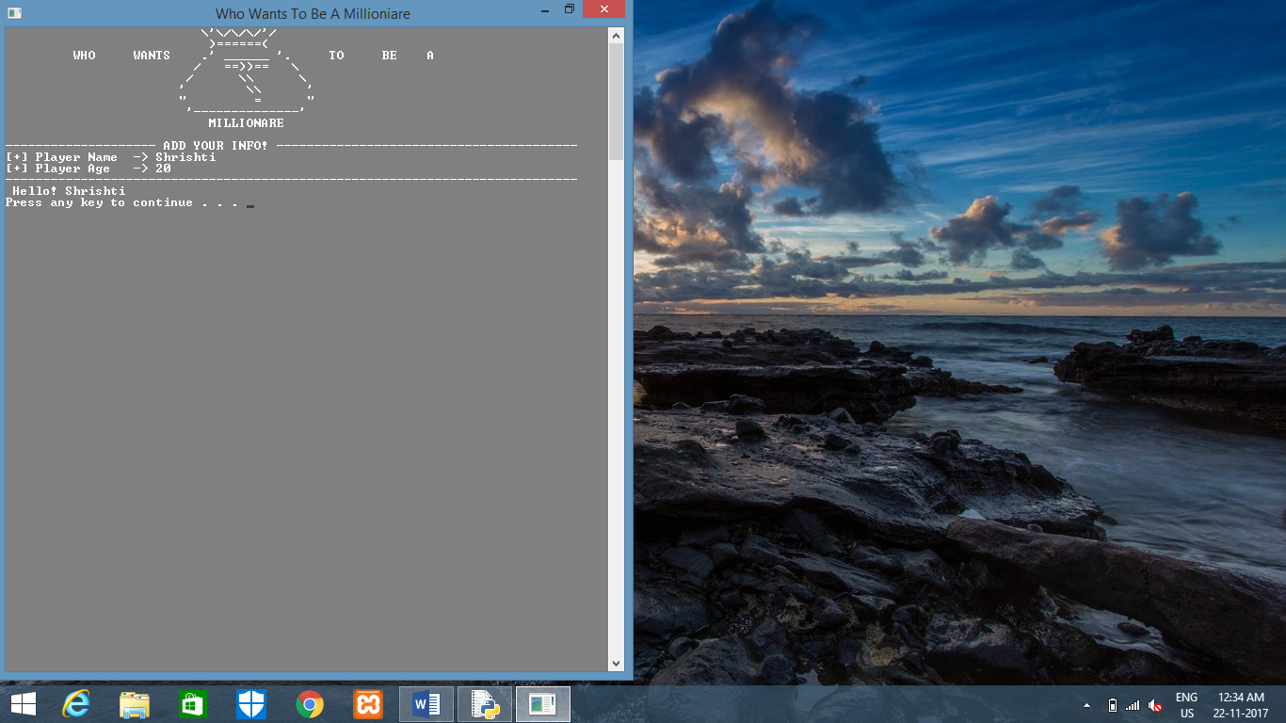

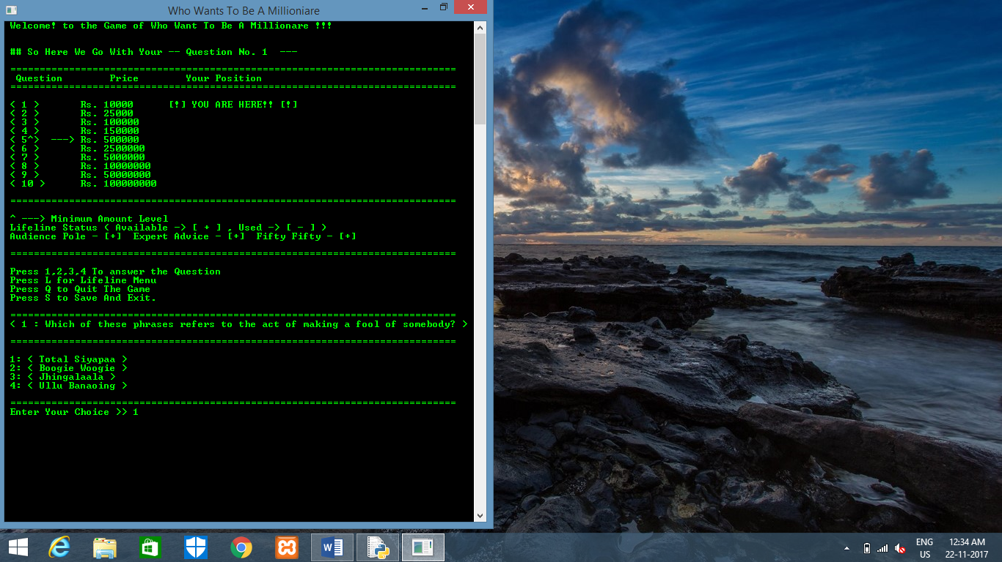

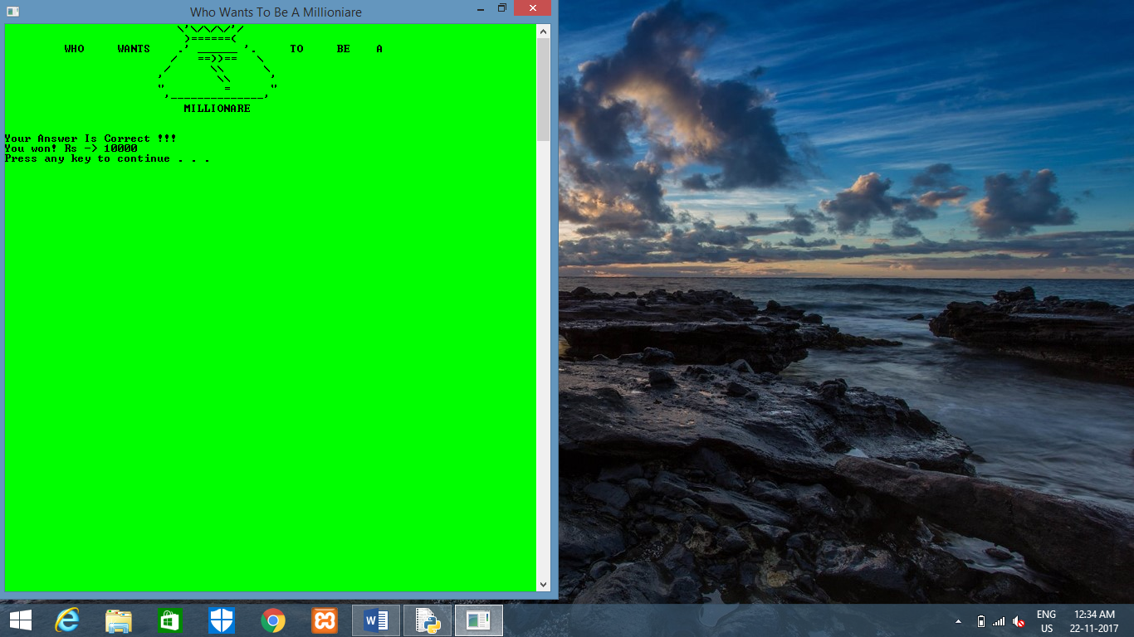

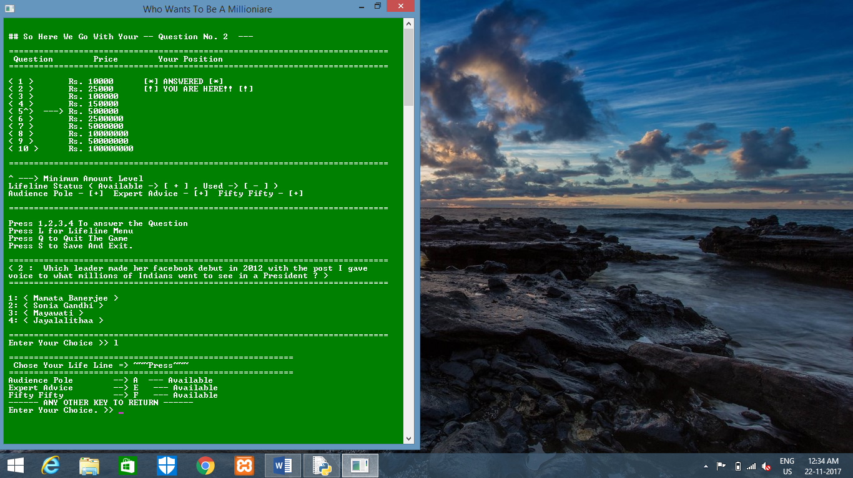

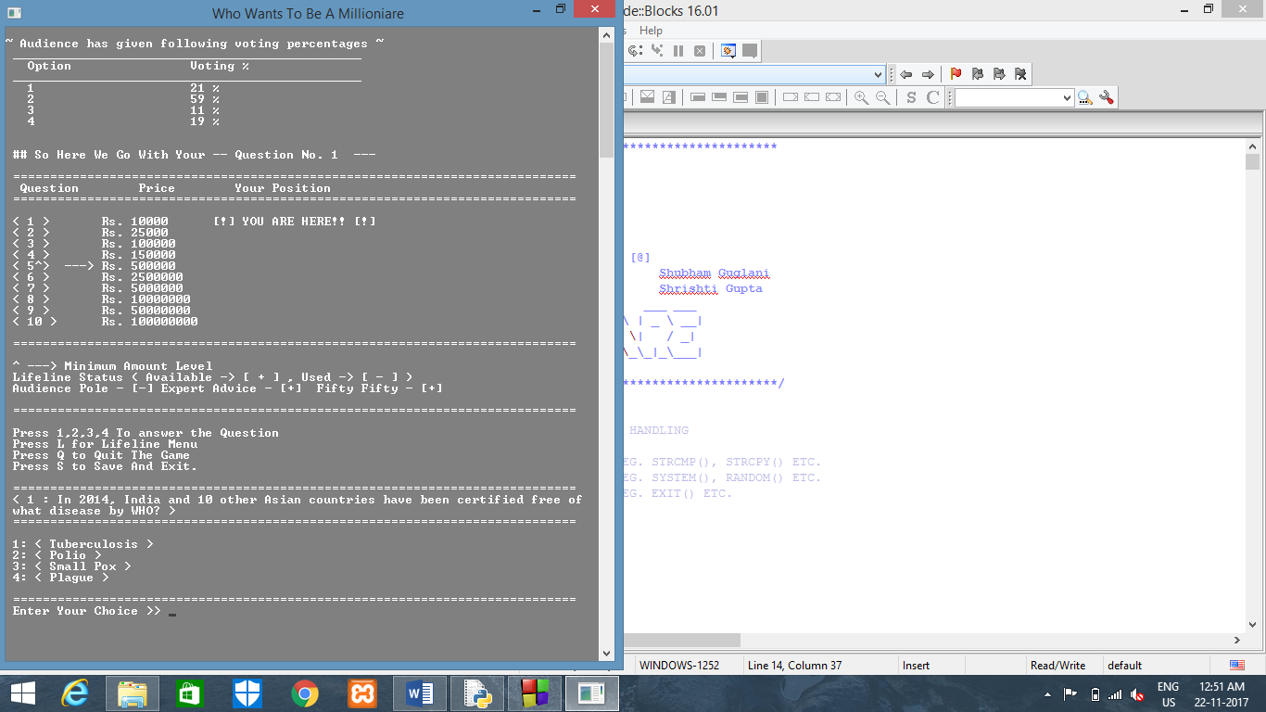

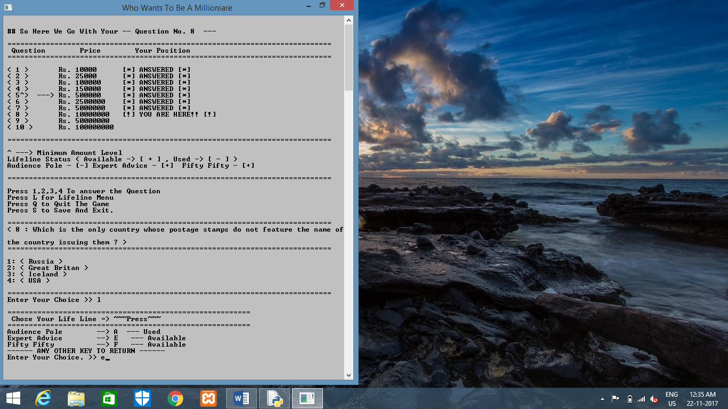

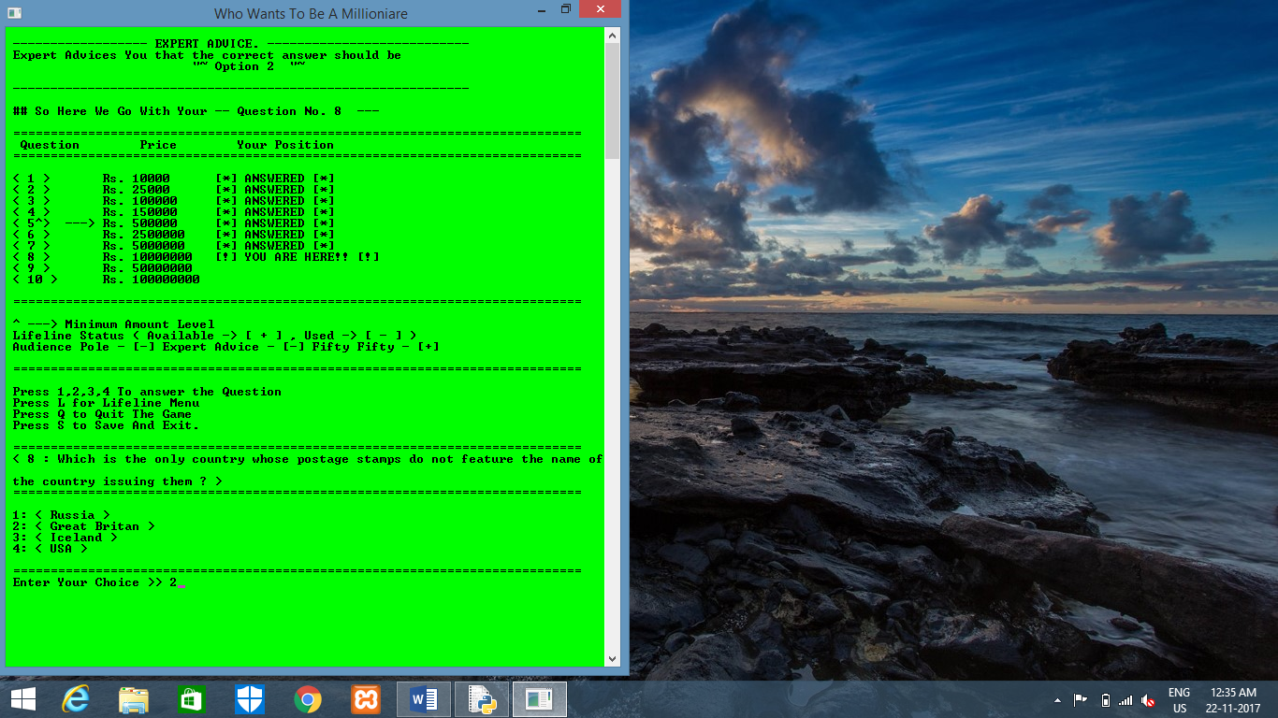

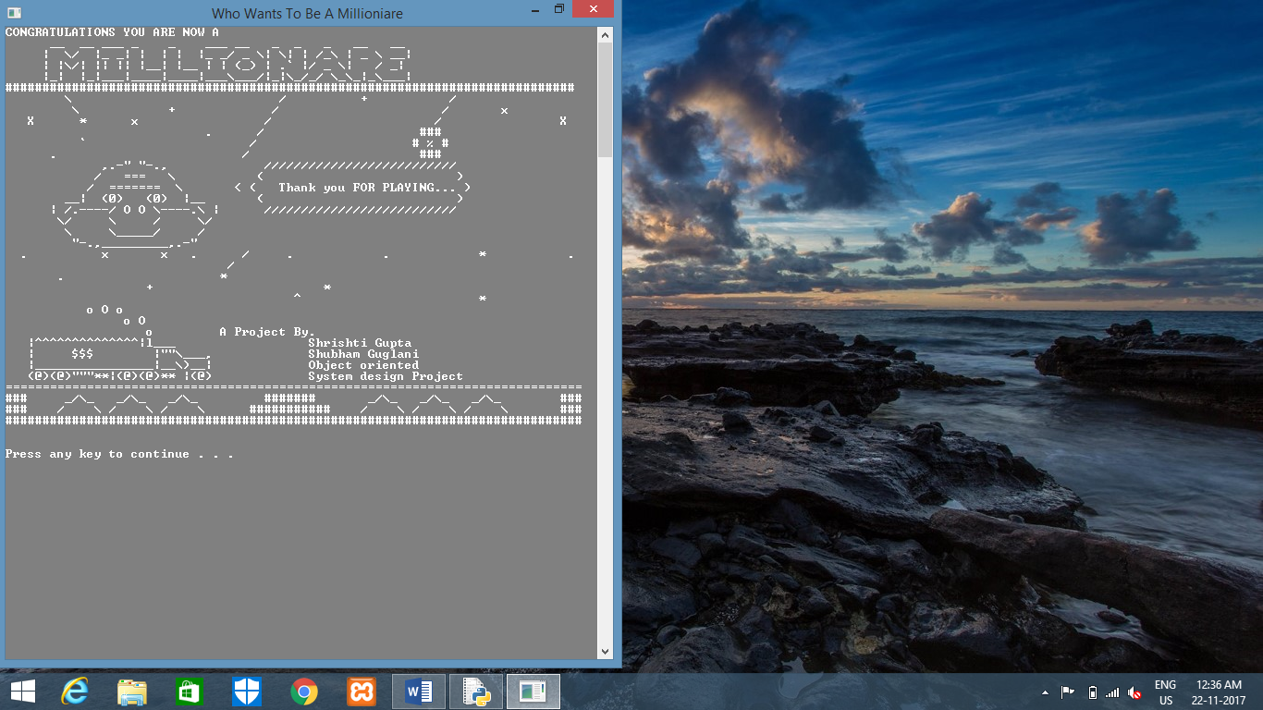

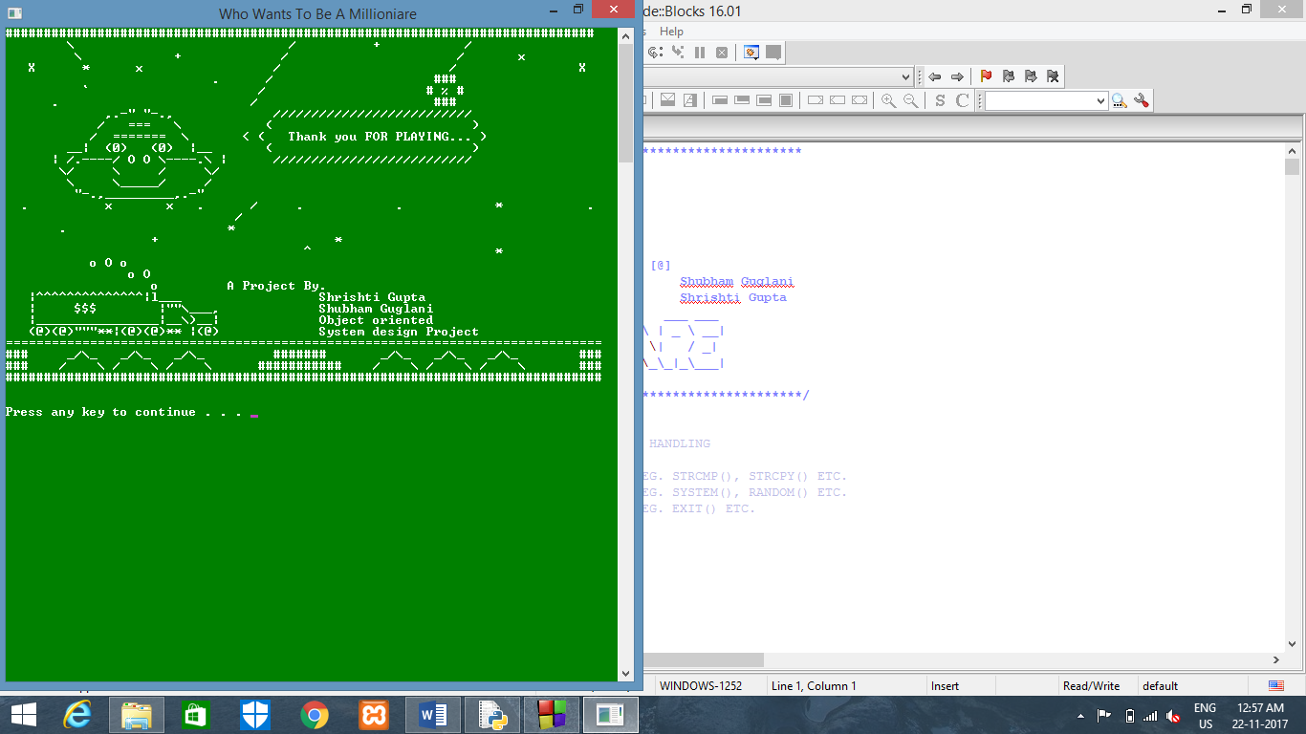

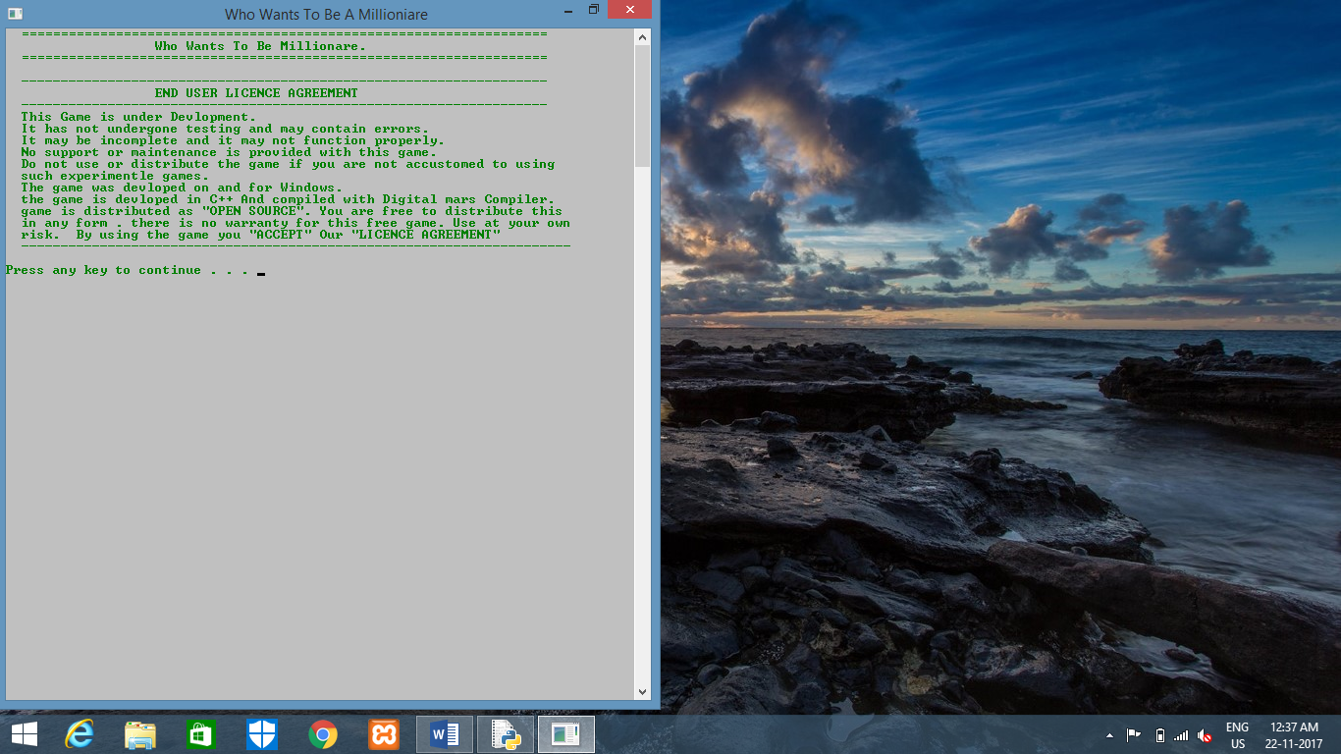

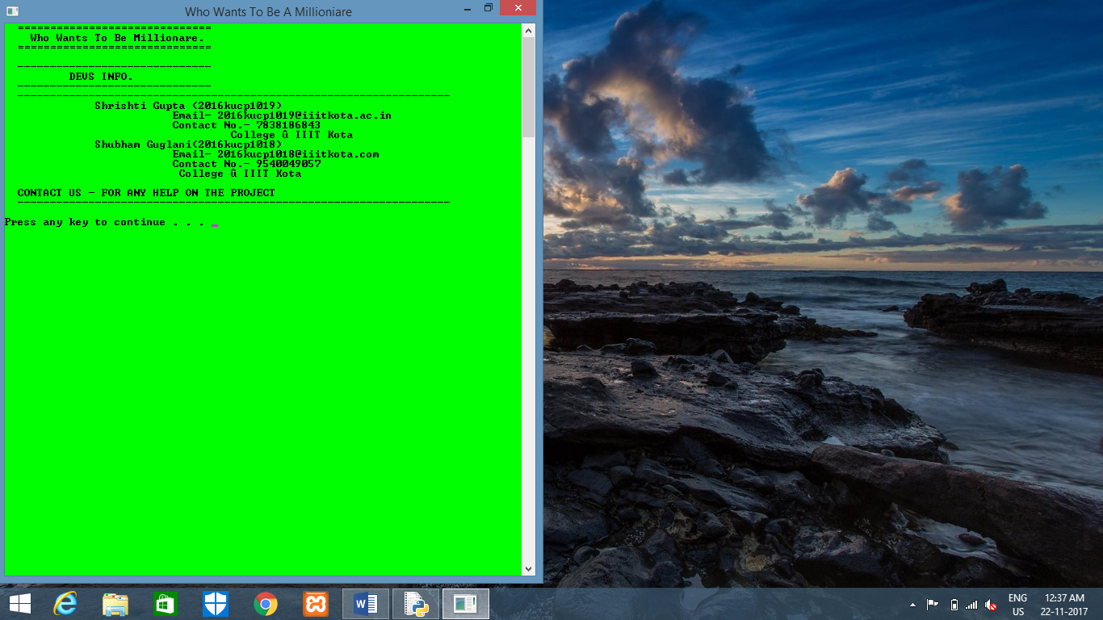

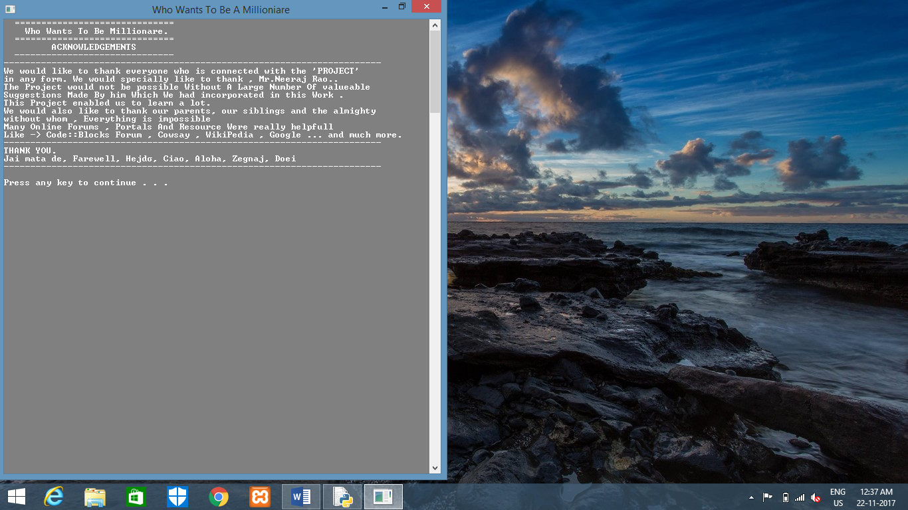

BIBLIOGRAPHY

1. Stack Overflow
2. Wikipedia
3. Google